CPDS Tool

Software Architecture Document

Revision History

|  |  |  |
| --- | --- | --- |
| **Date** | **Issue** | **Description** |
| July 17, 2003 | 0.1 | Initial version of the CPPE document |
| August 23, 2006 | 0.2 | Added new feature descriptions. (changed from CPPE to CPDS) |
|  |  |  |

Table of Contents

1. CPDS Purpose 4

2. Naming 4

3. Brief Document Description 4

4. Data Sources 5

5. Database Architecture 5

5.1 Database ERD 5

5.2 Database Support 6

6. Architectural Representation 6

7. Architectural Goals 6

8. Software Dependencies 7

9. Use-Case View 7

9.1 Create Farm 7

9.2 Define Field 8

9.3 Create Resource Management System 8

9.4 Create Report 8

10. Logical View 8

10.1 Architecture Overview 8

10.2 Architecturally-Significant Model Elements 8

10.2.1 Mechanisms 8

10.2.2 Common Elements & Services 9

11. User-Experience Model 9

11.1.1 CPDS Tool Navigation Map 9

12. Process View 10

13. Deployment View 11

13.1 Source Code Component Organization 12

14. System Size 12

15. References 12

Software Architecture Document

# CPDS Purpose

The CPDS Tool is a web based application that automates step 5 (decision support) of the 9-step NRCS conservation planning process. The CPDS Tool is based on Sections III, IV and V of the NRCS's eFOTG and the National Planning Procedures Handbook. These documents describe the process and relationships of practices and their effects, resource concerns, quality criteria, and relationships to a conservation plan. The application helps land owners and resource conservationists review current resource concerns in a given field or conservation management unit (CMU) and match them to sets of candidate conservation practices using the Conservation Practices Physical Effects (CPPE) data base.

The CPDS Tool supports the formulation of sets of conservation practices that address all identified resource concerns in a CMU. The end product of the CPDS Tool is a display and report of a comprehensive set of conservation practices defining resource management system alternatives. These alternatives can be viewed by the landowner to decide an effective course of treatment for the CMU being investigated.

In its current form, the CPDS Tool has undergone significant revision based on suggestions from reviewers especially from the National Technical Centers and the NRCS state office in Oregon. In some form, the tool may be incorporated into the Customer Service Toolkit, but it would be useful to have the functionality available on the web for public access also. As of August 2006, a more detailed assessment and review of the tool and how it could fit into the Field Office work flow is needed.

# Naming

The original name for this tool was the Conservation Practices Physical Effects (CPPE) Tool. Because of the need to better express its functionality, the tool was renamed to Conservation Planning Decision Support (CPDS) Tool.

# Brief Document Description

This document provides an architectural overview for the Conservation Practice Physical Effects tool. The purpose for this document is to convey the purpose and design ideas that are found behind the CPDS tool. The following is a simple diagram describing how the CPDS will function:

Interacts with the system

Interacts with the system

Tomcat Server

**Decision Maker**

**Soil Conservationist**

National DB

State DB

# Data Sources

All information used for both national and state (Oregon) databases was obtained from NRCS.

We had to make some assumptions to create both national and state databases. For the national database we do not have any cost information, so we are defaulting to using the Oregon cost list until the national list becomes available. For the state database, we are using the national practice-to-land-use mapping until such mapping is available for Oregon. Although currently the only state represented in the database is Oregon, it would be easy to add other states.

|  |  |  |  |  |  |
| --- | --- | --- | --- | --- | --- |
| **Database** | **DB Table** | **DB Variable** | **Workbook** | **Worksheet** | **Date** |
| National DB | effects | effect | CPPE-9June2005-National-Template.xls | Lookup | June 9th, 2005 |
| National DB | resource_problems | resource_prob | CPPE-9June2005-National-Template.xls | National QC | June 9th, 2005 |
| National DB | resource_problems | resource_prob_desc | CPPE-9June2005-National-Template.xls | National QC | June 9th, 2005 |
| National DB | resource_problems | quality_criteria | CPPE-9June2005-National-Template.xls | National QC | June 9th, 2005 |
| National DB | resource_categories | resource_cat | CPPE-9June2005-National-Template.xls | National QC | June 9th, 2005 |
| National DB | resource_categories | resource_cat | CPPE-7Nov2005-National-Template-HumanConsiderations.xls | HC Definitions | November 7th, 2005 |
| National DB | resources | resource | CPPE-9June2005-National-Template.xls | National QC | June 9th, 2005 |
| National DB | resources | resource | CPPE-7Nov2005-National-Template-HumanConsiderations.xls | HC Definitions | November 7th, 2005 |
| National DB | resource_practices | practice_name | CPPE-9June2005-National-Template.xls | Physical Effects | June 9th, 2005 |
| National DB | resource_practices | practice_description | CPPE-9June2005-National-Template.xls | Physical Effects | June 9th, 2005 |
| National DB | landuse_practices | exist | CPPE-7Nov2005-National-Template-HumanConsiderations.xls | Human Considerations | November 7th, 2005 |
| National DB | land_use | land_use | CPPE-7Nov2005-National-Template-HumanConsiderations.xls | Human Considerations | November 7th, 2005 |
| National DB | cost_list | unit | RMSPlanningToolHG010206.xls (based on Oregon) | CostList | January 2nd, 2006 |
| National DB | cost_list | installation_cost | RMSPlanningToolHG010206.xls (based on Oregon) | CostList | January 2nd, 2006 |
| National DB | cost_list | life_year | RMSPlanningToolHG010206.xls (based on Oregon) | CostList | January 2nd, 2006 |
| National DB | cost_list | installation_cost_yr | RMSPlanningToolHG010206.xls (based on Oregon) | CostList | January 2nd, 2006 |
| National DB | cost_list | om_factor | RMSPlanningToolHG010206.xls (based on Oregon) | CostList | January 2nd, 2006 |
| National DB | cost_list | om_cost_yr | RMSPlanningToolHG010206.xls (based on Oregon) | CostList | January 2nd, 2006 |
| National DB | cost_list | total_annual_cost | RMSPlanningToolHG010206.xls (based on Oregon) | CostList | January 2nd, 2006 |
| Oregon DB | effects | effect | CPPE-9June2005-National-Template.xls | Lookup | June 9th, 2005 |
| Oregon DB | resource_problems | resource_prob | OregonCPPEMatrix070506.xls | Definitions | June 9th, 2005 |
| Oregon DB | resource_problems | resource_prob_desc | OregonCPPEMatrix070506.xls | Definitions | June 9th, 2005 |
| Oregon DB | resource_problems | quality_criteria | CPPE-9June2005-National-Template.xls | National QC | June 9th, 2005 |
| Oregon DB | resource_categories | resource_cat | OregonCPPEMatrix070506.xls | Definitions | June 9th, 2005 |
| Oregon DB | resources | resource | OregonCPPEMatrix070506.xls | Definitions | June 9th, 2005 |
| Oregon DB | resource_practices | practice_name | OregonCPPEMatrix070506.xls | CPPE | June 9th, 2005 |
| Oregon DB | resource_practices | practice_description | OregonCPPEMatrix070506.xls | Physical Effects | June 9th, 2005 |
| Oregon DB | landuse_practices | exist | CPPE-8June2004.xls | Practice Land Uses | June 8th, 2004 |
| Oregon DB | land_use | land_use | CPPE-8June2004.xls | Practice Land Uses | June 8th, 2004 |
| Oregon DB | cost_list | unit | RMSPlanningToolHG010206.xls | CostList | January 2nd, 2006 |
| Oregon DB | cost_list | installation_cost | RMSPlanningToolHG010206.xls | CostList | January 2nd, 2006 |
| Oregon DB | cost_list | life_year | RMSPlanningToolHG010206.xls | CostList | January 2nd, 2006 |
| Oregon DB | cost_list | installation_cost_yr | RMSPlanningToolHG010206.xls | CostList | January 2nd, 2006 |
| Oregon DB | cost_list | om_factor | RMSPlanningToolHG010206.xls | CostList | January 2nd, 2006 |
| Oregon DB | cost_list | om_cost_yr | RMSPlanningToolHG010206.xls | CostList | January 2nd, 2006 |
| Oregon DB | cost_list | total_annual_cost | RMSPlanningToolHG010206.xls | CostList | January 2nd, 2006 |

# Database Architecture

To understand the CPDS database architecture, a simple entity relationship diagram (ERD) will be used to provide an architectural overview of the underlying CPDS data.

## Database ERD

An ER diagram provides a high-level description of a conceptual data model. In the case of the CPDS, the following ER diagram describes the relationships between the tables within the database. Note that the following architecture applies to both national and state databases.

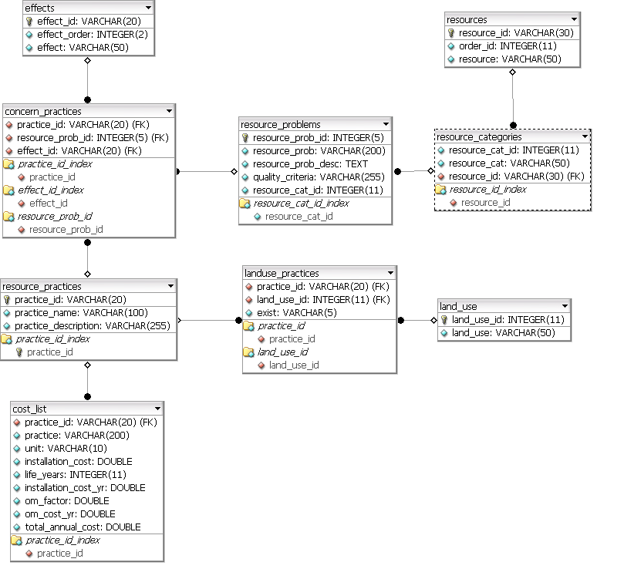

## Database Support

Some of these databases are currently supported by the NRCS. The tool should ultimately access the authoritative version maintained by the NRCS.

As the CPDS tool becomes widely used, there will be a need for NRCS to continue future support of national, state and Common Resource Area (CRA) databases.

# Architectural Representation

The architecture of the CPDS is represented by following these six models:

* Use Case View
* Logical View
* User Experience Model
* Process View
* Deployment View

# Architectural Goals

The CPDS has been created with the following goals in mind:

1. To help agricultural producers and soil conservationists in identifying and reviewing current resource concerns in a given field.
2. To find the best possible set of conservations practices that can be used to address the resource concerns.
3. To create a set of management system alternatives and to facilitate the selection of the best alternative for the current field.
4. To record the flow of the decision as part of National Environmental Policy Act (NEPA) documentation.

# Software Dependencies

The CPDS Tool uses the following technologies:

1. Tomcat 5.0 JSP and Servlet container
2. MySQL Database v4.0.12-nt

Tomcat 5.0 implements the Servlet 2.4 and Java Server Pages 2.0 specifications.

This application has been created as a self-contained entity. Integration as a part of a greater system (the Conservation Planning Support System) will happen in the future and the glue will be XML.

Database access is done at the DB engine level. MySQL is being used as the database engine.

# Use-Case View

The functionality of the CPDS can be summarized with the following use cases:

Soil

Conservationist

**CPDS System Use Case View**

Decision

Maker

## Create Farm

Brief Description: The user has the options to: 1) create a quick management system for a single management unit based on a default farm name and default field name, 2) create a customized farm that could contain many fields, or 3) open an existing farm.

## Define Field

Brief Description: This use case allows a user to define the field. During this step the user will be required to provide the planning site information, the land use that will be used to filter on practices and concerns, and, if creating a customized farm, the name of the field.

The user must also decide how he/she will be entering the resource concerns. The system currently provides two methods. One is to select the resource concerns from a list and the other option is to upload a text file that is read by the CPDS. The intention in supporting a text file, is so that a PDA could be used in the field for the inventory of resource concerns and the inventory could be used directly, without re-entering the list of identified concerns.

## Create Resource Management System

Brief Description: The user must select from a list of concerns that are provided based on the selected database and landuse. The user is then required to select a set of practices based on the selected concerns. Once these steps are completed, the user will have done all necessary steps to build the resource management system matrix. The system will insert the concerns and practices with their corresponding effects. Each practice (table row) will be sorted such that the row with the most positive effects on all concerns will be on top.

## Create Report

Brief Description: Once the user has created the matrix and each concern has been marked as either meeting or not meeting quality criteria, the management system will be save and a report will be created. The final report will have:

1. the planning site information,
2. the resource management system matrix
3. the selected concerns
4. the considered practices (with economic information)
5. the selected practices (with economic information)

# Logical View

This section describes the logical structure of the CPDS system. First it examines the architecture, then the structural behavior of the system.

## Architecture Overview

The architecture of the CPDS is mainly based on JSP, a MySQL Database, DHTML, and JavaScript.

## Architecturally-Significant Model Elements

### Mechanisms

The CPDS application makes extensive use of JSPs:

The JSP mechanism that the system uses follows one of the Sun J2EE patterns. The mechanism used is the View Helper Pattern. This works by separating the view from the logic. This separation is done through the use of a helper. In this case the helpers are JavaBeans. Even though most of the logic is put inside the helpers, it was necessary to incorporate some of the logic into the JSPs. This was done in form of scriplets. The system also utilizes other helpers, such as JavaScript functions on the client side. This was done for interactivity purposes and good user experience. The JavaScript code was not included as helpers because it is considered part of the View. However, this has been included in the “Common Elements and Services” section below.

The following sequence diagram demonstrates how the system accepts requests and processes them:

**User**

**View(JSP)**

**Helper (JavaBeans)**

**Data Source (DB)**

1: Get Data

1.1: Get Data

1.1.1: Get Data

1.1.1.1: Return Data

### Common Elements & Services

The following are some common elements and services that belong to the CPDS framework:

* Utility Classes
* XML Parser
* JavaScript classes

#### Utility Classes and XML Parser

The Utility Classes and the XML Parser packages contain support elements for the CPDS. The XML Parser contains a utility Java class that loads and parses XML files.

#### JavaScript classes

The JavaScript classes are a collection of scripts that are used by the CPDS to process XML and to perform other miscellaneous functions.

# User-Experience Model

The user experience model captures the screen presented to the user in the CPDS and the transitions between screens which is a result from user-generated events, like clicking on a button.

The user experience model consists of:

* Navigational maps, the transition between application screens

### CPDS Tool Navigation Map

The diagram below shows CPDS navigation map. The diagram shows screen-to-screen transition, which the user must traverse to complete the whole CPDS process.

The relationships between objects represent the transitions between screens initiated by the user’s actions.

**CPDS Tool Navigation Map**

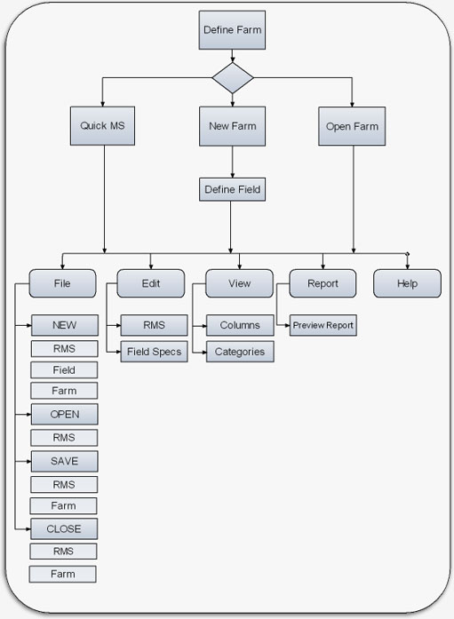

# Process View

The process view shows the assignment of active classes to the operating systems processes and threads. This view shows, through an activity diagram, how the system will flow.

**Activity Diagram for the CPDS Tool**

Select Resource Concerns

Browse to specify a formatted text file

Select Management Practice

Modify Practice/Concern Effects

Show a Report (HTML or Word Document)

Check “Meets Quality Criteria”

Select Land Use

Enter Planning Site Information

Create RMS

Create Farm

Open Farm

# Deployment View

The deployment view of the CPDS shows the physical nodes on which the system executes and the assignment system pieces to their corresponding nodes. The following diagram below shows the most typical deployment configuration used by development teams.

Client

Application Server

Browser

Web Container   
(JSPs, JavaScript, DHTML, XHTML) X)

MySQL SQL Calls

Database Server

## Source Code Component Organization

The structure of the system components representing the Java and JSP source-code units reflects the logical structure of the system. The following image is a graphical description of the file structure of the deployable CPDS system.

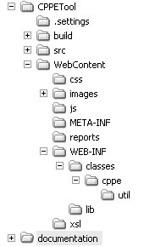

# System Size

The CPDS application’s size is described with the following items:

* Dependencies on external components: 5
* Lines of Java code: approximately 1500
* Java source files: 6
* JSP files: 15
* JavaScript files: 7
* CSS files: 1
* XSL files: 1

# References

Some of the reference materials used to build the CPDS system are the following:

* *USDA/NRCS National Planning Procedures Handbook*
* *XML in a Nutshell: Harold and Means (O’Reilly)*
* *JavaScript, The Definitive Guide*: *Flannagan (O’Reilly)*
* *Dynamic HTML, The Definitive Guide: Goodman (O’Reilly)*
* *The Unified Modeling Language Reference Manual: Rumbaugh, Jacobson, Booch*